Maharashtra State Board of Technical Education

Government polytechnic Solapur

 

DIPLOMA IN INFORMATION TECHNOLOGY

(IF)2023-2024

**Academic Year 2023-2024**

A

Micro Project on

**Quiz Application**

Group Members

|  |  |  |  |
| --- | --- | --- | --- |
| **Roll No** | **Name of the Group Members** | **Enrolment No** | **Exam Seat No** |
| 15 | Dharashivkar Aditya Mahesh | 2100150261 |  |
| 23 | Sawalgi Shriyash Balasaheb | 2100150275 |  |
| 36 | Makude Kaustubh Ishwar | 2100150298 |  |
| 41 | Maske Abhishek Sunil | 2100150303 |  |

**Under the Guidance of:**

Prof. Bhorkar Mam

Government polytechnic Solapur

Certificate

|  |  |  |  |
| --- | --- | --- | --- |
| **Roll No** | **Name of the Group Members** | **Enrolment No** | **Exam Seat No** |
| 15 | Dharashivkar Aditya Mahesh | 2100150261 |  |
| 23 | Sawalgi Shriyash Balasaheb | 2100150275 |  |
| 36 | Makude Kaustubh Ishwar | 2100150298 |  |
| 41 | Maske Abhishek Sunil | 2100150303 |  |

Certified that this Microproject Report

**Quiz Application**

In this work.

The Students of Semester Fifth Advance Java Programming (AJP). Diploma in Information technology 2023-2024 Partial fulfilment for the Award of Diploma in information technology branch by MSBTE

Sign of Subject Teacher Sign of principal

**Prof. Bhorkar Mam** **Dr. Ashok Upadhyay**

Part-A Microproject Report

1. **Title of Microproject:**

Quiz Application

**2.0 Brief Introduction:**

Weather applications serve a crucial role in providing users with up-to-date meteorological data, enabling them to make informed decisions. With the advancement of technology and the proliferation of web-based applications, the demand for intuitive, real-time weather information has never been higher. Our project aims to address this demand by developing a simple yet effective weather application that can be accessed via web browsers on various devices.

**3.0 Aim of the micro-project:**

Weather Application development using API’s and JavaScript functions

**4.0 Intended course outcomes:**

* Decide suitable software for project
* Choose correct languages for development
* Lean how to implement JavaScript in web pages
* Learn how to manipulate data from the API’s

**5.0 Literature review:**

In an era where information is readily accessible at our fingertips, weather forecasts have become an integral part of our daily lives. Whether planning a weekend getaway, deciding what to wear, or simply staying informed about local weather conditions, a reliable and user-friendly weather application is a valuable tool. In response to this need, we embark on a journey to create a basic weather application using JavaScript, one of the most versatile and widely-used programming languages in web development.

Weather applications serve a crucial role in providing users with up-to-date meteorological data, enabling them to make informed decisions. With the advancement of technology and the proliferation of web-based applications, the demand for intuitive, real-time weather information has never been higher. Our project aims to address this demand by developing a simple yet effective weather application that can be accessed via web browsers on various devices.

As we embark on this project, we envision a user-friendly and informative weather application that simplifies the way individuals interact with weather data. Through the power of JavaScript and modern web development techniques, we aim to create a valuable tool that empowers users to make informed decisions based on real-time weather information. Join us on this journey as we bring this vision to life and contribute to the world of accessible weather forecasting.

**6.0 Proposed Methodology:**

1. Discussion about given topic.
2. Selection of group leader and distribution of responsibility.
3. Collection of information using different resources.
4. Analysis of information as per format given.
5. Represent of information and required format.
6. Preparation of project report.
7. Complications of and submission of given assign task

**7.0 Resources required:**

|  |  |  |  |
| --- | --- | --- | --- |
| **Sr. No** | **Name Of resources** | **Quantity** | **Remarks** |
| 1 | Books | JavaScript Demystified |  |
| 2 | PC/ laptop | hp computer Processor- Intel(R) Core (TM) i5-8365U CPU @ 1.60GHz 1.90 GHz  Installed Memory- (RAM)16:00GB System type - 64-byte operating system. |  |

**8.0 Action plan:**

|  |  |  |
| --- | --- | --- |
| **Sr. No** | **Details of activity** | **Number of students** |
| 1 | Discussion | 15 Dharashivkar Aditya Mahesh  23 Sawalgi Shriyash Balasaheb  36 Makude Kaustubh Ishwar  41 Maske Abhishek Sunil |
| 2 | Collection of Information | 15 Dharashivkar Aditya Mahesh  23 Sawalgi Shriyash Balasaheb  36 Makude Kaustubh Ishwar  41 Maske Abhishek Sunil |
| 3 | Analysis of Information | 15 Dharashivkar Aditya Mahesh  23 Sawalgi Shriyash Balasaheb  36 Makude Kaustubh Ishwar  41 Maske Abhishek Sunil |
| 4 | Coding | 15 Dharashivkar Aditya Mahesh  23 Sawalgi Shriyash Balasaheb  36 Makude Kaustubh Ishwar  41 Maske Abhishek Sunil |
| 5 | Preparation of Report | 15 Dharashivkar Aditya Mahesh  23 Sawalgi Shriyash Balasaheb  36 Makude Kaustubh Ishwar  41 Maske Abhishek Sunil |

Part-b Microproject Report

1. **Title of Microproject:**

Weather Application

**2.0 Aim of the micro-project:**

To Weather Application using JavaScript to make the application interactive

**3.0 Course Outcomes:**

1. Create interactive web pages using program flow control structure.
2. Implement arrays and functions in JavaScript.
3. Create event-based web forms using JavaScript.
4. Use JavaScript for handling cookies.
5. Create interactive web pages using regular expressions for validations.
6. Create Menus and Navigations in web pages.

**4.0 Literature review:**

**Introduction to JavaScript and Web Development:**

* Discuss the importance of JavaScript in modern web development.
* Highlight the role of JavaScript in creating dynamic and interactive web applications.
* Introduce the project's focus on building a basic weather application.

**Client-Side Development:**

* Explore the concept of client-side development and its significance in creating web applications.
* Discuss the advantages of client-side development, such as improved user experience and reduced server load.

**JavaScript Frameworks and Libraries:**

* Review popular JavaScript libraries and frameworks, such as React, Angular, and Vue.js.
* Evaluate the suitability of these frameworks for building weather applications.
* Discuss the benefits of using a framework to enhance code organization and maintainability.

**API Integration:**

* Examine the importance of APIs (Application Programming Interfaces) in web development.
* Explore different weather data APIs like OpenWeatherMap, WeatherAPI, and AccuWeather.
* Discuss how to make API requests using JavaScript and handle responses.

**Asynchronous JavaScript:**

* Explain the concept of asynchronous programming in JavaScript.
* Discuss the use of promises and async/await for handling asynchronous tasks, such as fetching weather data from an API.

**User Interface (UI) Design:**

* Review principles of UI/UX design for web applications.
* Discuss responsive web design for ensuring the weather app works on various devices and screen sizes.
* Present design considerations for user-friendly weather application interfaces.

**Geolocation and Mapping:**

* Explore the geolocation API in JavaScript for obtaining the user's location.
* Discuss the integration of mapping libraries like Leaflet or Google Maps for visualizing weather data.

**Data Visualization:**

* Discuss techniques for visualizing weather data, such as charts and graphs.
* Review JavaScript libraries like Chart.js and D3.js for creating interactive data visualizations.

**Error Handling and Validation:**

* Explain how to handle errors gracefully in JavaScript applications.
* Discuss input validation and error messages for improving user experience.

**Security Considerations:**

* Address security concerns when working with APIs, such as API key management.
* Discuss best practices for securing user data and connections in web applications.

**Testing and Debugging:**

* Review tools and techniques for testing and debugging JavaScript applications.
* Discuss unit testing, end-to-end testing, and debugging using browser developer tools.

**Performance Optimization:**

* Explore strategies for optimizing the performance of the weather application, such as caching weather data and minimizing API requests.

**Accessibility:**

* Explain the importance of accessibility in web development.
* Discuss techniques for making the weather application accessible to users with disabilities.

**Deployment and Hosting:**

* Explore different hosting options for deploying a JavaScript weather application.
* Discuss continuous integration and continuous deployment (CI/CD) pipelines for automating deployment processes.

**Conclusion and Future Work:**

* Summarize the key findings from the literature review.
* Suggest potential areas for further research or enhancements to the weather application.
* By conducting a comprehensive literature review on these topics, you'll be well-prepared to design and develop your basic weather application using JavaScript and the best practices in web development.

By conducting a comprehensive literature review on these topics, you'll be well-prepared to design and develop your basic weather application using JavaScript and the best practices in web development.

**5.0 Actual methodology:**

* Discussion about given topic.
* Selection of group leader and distribution of responsibility.
* Collection of information using different resources.
* Analysis of information as per format given.
* Represent of information and required format.
* Preparation of project report.
* **Code for Weather Application**
* HTML file with Inline & Embedded styling:

<!DOCTYPE html>

<html>

<head>

<meta charset="UTF-8">

<meta name="viewport" content="width=device-width, initial-scale=1.0">

<link rel="stylesheet" href="../node_modules/bootstrap/dist/css/bootstrap.css">

<link rel="stylesheet" href="../node_modules/bootstrap-icons/font/bootstrap-icons.css">

<title>Weather Application</title>

<style>

.card{

max-width: 470px;

background: -moz-linear-gradient(135deg,#a2eeda,#a69ed4);

color: rgb(179, 89, 89);

font-weight: 100;

margin: 100px auto 0;

border-radius: 20px;

padding: 40px 35px;

text-align: center;

margin-top: 4px;

}

.search{

width: 100%;

display: flex;

align-items: center;

justify-content: center;

}

body{

background-image: url('https://img.freepik.com/free-vector/sky-background-video-conferencing_23-2148639325.jpg');

width: 1200px;

height: 600px;

background-size: 1500px 700px;

}

</style>

</head>

<body class=" d-flex justify-content-center align-items-center text-center" style="width: 1500px;height: 560;" style="background-repeat: no-repeat;" onload="setValues()">

<div id="card" class="card" style="width: 400px; height: 560px;">

<div class="search">

<button id="fullscreen" class="btn btn-light me-3" style="border: 0; border-radius: 50%;"><span class="bi bi-arrows-fullscreen"></span></button>

<input type="text"class="form-control me-3" name="" id="" placeholder="Enter city name" spellcheck="false">

<button id="searchbtn" class="btn btn-light" style="border: 0; border-radius: 50%;"><span class="bi bi-search"></span></button>

</div>

<div class="weather">

<br>

<h2 class="date" id="date" style="font-size: 30px;"></h2>

<h2 class="time" id="time" style="font-size: 25px;"><span id="am_pm"></span></h2>

<span class="temp" id="temp" style="font-size: 25px;"></span>

<span class="city" id="city" style="font-size: 25px;"></span>

<div class="row">

<div class="col">

<span class="bi bi-clouds-fill"></span>

<div>

<p class="humidity" id="humidity" style="font-size: small;"></p>

<p style="font-size: small;">Humidity</p>

</div>

</div>

<div class="col">

<span class="bi bi-wind"></span>

<div>

<p class="wind" style="font-size: small;"></p>

<p style="font-size: small;">Wind speed</p>

</div>

</div>

</div>

<div class="row">

<div class="col">

<span class="bi bi-thermometer-low">°C</span>

<div>

<p class="temp_min" id="temp_min" style="font-size: small;"></p>

<p style="font-size: small;">Minimum Tempreture</p>

</div>

</div>

<div class="col">

<span class="bi bi-thermometer-high">°C</span>

<div>

<p class="temp_max" style="font-size: small;"></p>

<p style="font-size: small;">Maximum tempreture</p>

</div>

</div>

</div>

<div id="weatherOnFull" style="visibility: hidden;">

<div class="row">

<div class="col">

<span class="bi bi-speedometer"></span>

<div>

<p class="Pressure" id="Pressure" style="font-size: small;"></p>

<p style="font-size: small;">Pressure</p>

</div>

</div>

<div class="col">

<span class="bi bi-water"></span>

<div>

<p class="SeaLevel" id="SeaLevel" style="font-size: small;"></p>

<p style="font-size: small;">Sea Level</p>

</div>

</div>

<div class="col">

<span class="bi bi-house-fill"></span>

<div>

<p class="GroundLevel" style="font-size: small;"></p>

<p style="font-size: small;">Ground Level</p>

</div>

</div>

</div>

<div class="row">

<div class="col">

<span class="bi bi-eye"></span>

<div>

<p class="visibility" id="visibility" style="font-size: small;"></p>

<p style="font-size: small;">Visibility</p>

</div>

</div>

<div class="col">

<span class="bi bi-sunrise-fill"></span>

<div>

<p class="sunRise" id="sunRise" style="font-size: small;"></p>

<p style="font-size: small;">Sun Rise Time</p>

</div>

</div>

<div class="col">

<span class="bi bi-sunset-fill"></span>

<div>

<p class="sunSet" style="font-size: small;"></p>

<p style="font-size: small;">Sun Set Time</p>

</div>

</div>

</div>

</div>

</div>

</div>

<script src="script.js"></script>

</body>

</html>

* JavaScript file implementing API fetching and another functions

const apikey = "f349017823b2dcc53dba584a69f214dd";

const apiurl = "https://api.openweathermap.org/data/2.5/weather?units=metric&q=";

const searchbox = document.querySelector(".search input");

const searchbtn = document.getElementById("searchbtn");

const fullscreen = document.getElementById("fullscreen");

var state=false;

async function checkWeather(city){

const response = await fetch(apiurl+city+`&appid=${apikey}`);

var data = await response.json();

console.log(data);

var sunrise = new Date(data.sys.sunrise);

var sunset = new Date(data.sys.sunset);

document.querySelector(".city").innerHTML = data.name;

document.querySelector(".temp").innerHTML = Math.round(data.main.temp)+" °C";

document.querySelector(".humidity").innerHTML = data.main.humidity+" %";

document.querySelector(".wind").innerHTML = data.wind.speed+" km/hr";

document.querySelector(".temp_min").innerHTML = data.main.temp_min;

document.querySelector(".temp_max").innerHTML = data.main.temp_max;

if(state){

document.querySelector(".Pressure").innerHTML=data.main.pressure+" Pa";

document.querySelector(".SeaLevel").innerHTML=data.main.sea_level+" meters";

document.querySelector(".GroundLevel").innerHTML=data.main.grnd_level+" meters";

document.querySelector(".visibility").innerHTML=data.visibility;

document.querySelector(".sunRise").innerHTML=sunrise.getHours()+" : "+sunrise.getMinutes();

document.querySelector(".sunSet").innerHTML=sunset.getHours()+" : "+sunset.getMinutes();

}else{

document.getElementById("card").style="width: 400px; height: 560px";

document.getElementById("weatherOnFull").style.visibility= "hidden";

}

}

async function showWeatherOnFullScreen(){

document.getElementById("card").style="width: 1100px";

document.getElementById("weatherOnFull").style.visibility= "visible";

}

fullscreen.addEventListener("click",()=>{

state=!state;

if (state) {

showWeatherOnFullScreen();

checkWeather(searchbox.value);

}else{

checkWeather(searchbox.value);

}

});

searchbtn.addEventListener("click",()=>{

checkWeather(searchbox.value);

})

const timel = document.getElementById("time");

const datel = document.getElementById("date");

const days = ["Sunday","Monday","Tuesday","Thursday","Friday","Saturday"];

const months = ["Jan","Feb","Mar","Apr","May","Jun","Jul","Aug","Sep","Oct","Nov","Dec"];

setInterval(()=>{

const time = new Date();

const month =time.getMonth();

const date = time.getDate();

const day = time.getDay();

const hour = time.getHours();

const hoursIn12HrFormat = hour >=13 ? hour%12 : hour;

const minutes = time.getMinutes();

const ampm = hour>=12 ? "PM" : "AM";

timel.innerHTML = (hoursIn12HrFormat<10?0+hoursIn12HrFormat:hoursIn12HrFormat)+" : "+minutes+ampm;

datel.innerHTML = days[day]+", "+date+" "+months[month];

}, 1000);

* **Output**

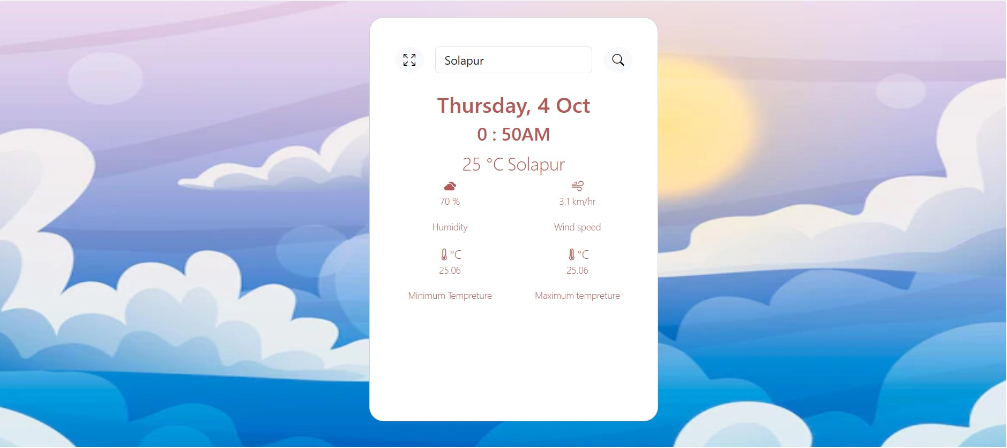

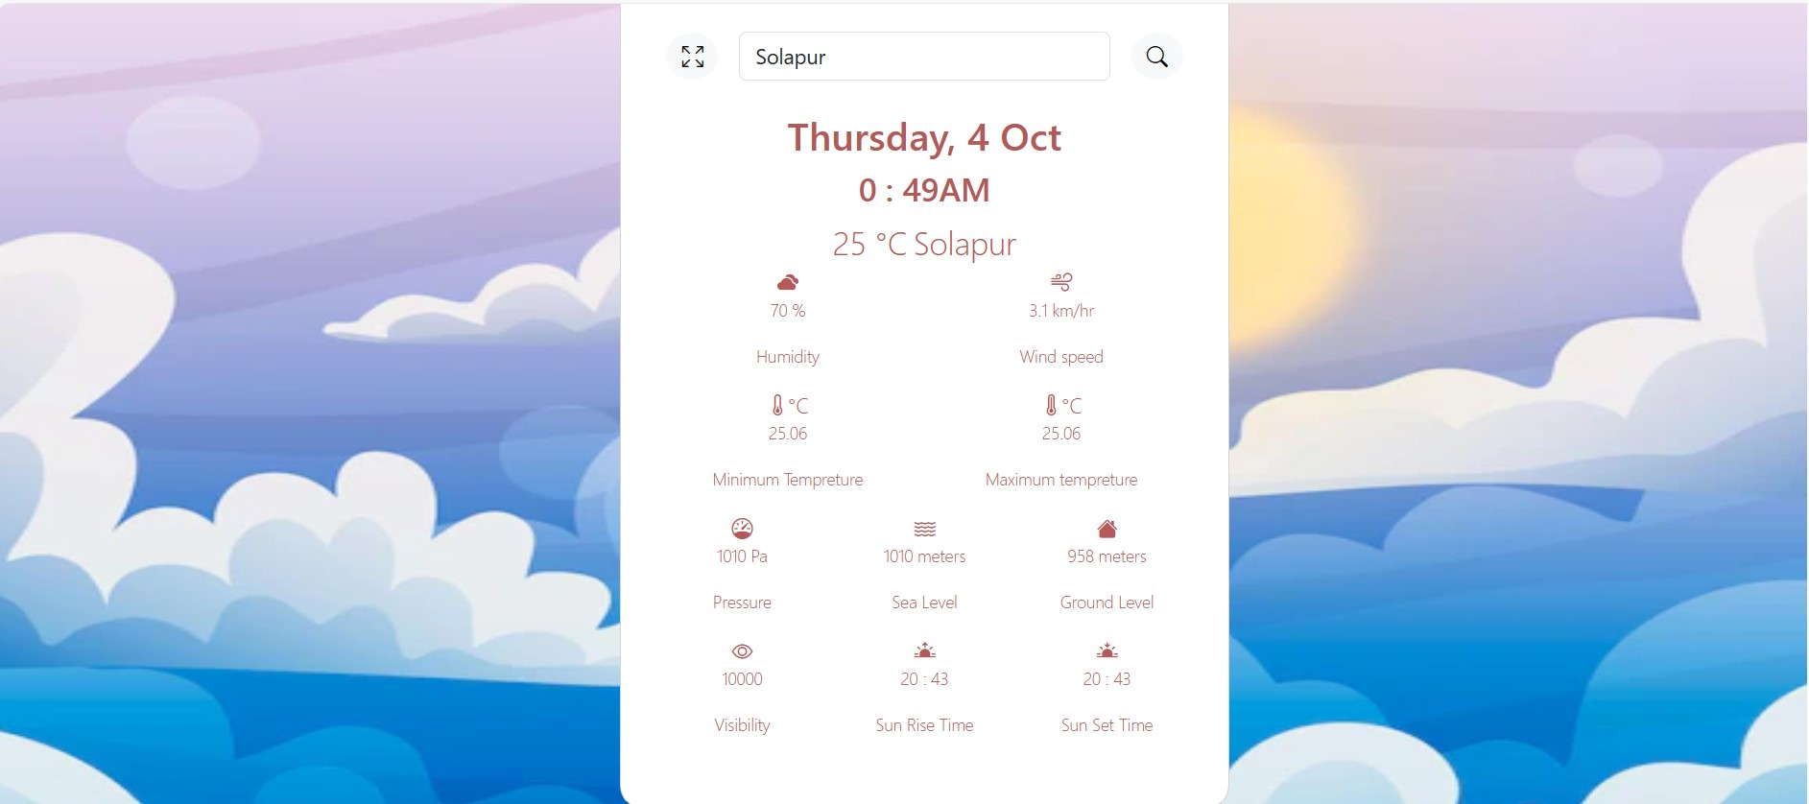

1. **Skill developed:**

**Leadership:**

If we have learnt anything this project is that great leadership is an Essential skill to be a good project manager our leadership hole means We lead a manage teem setting in vision and motivating the learn.

**8.0 Area of feature:**

Using this Project, we display the weather details of all the cities in the world by fetching their respective data from an API provided by OpenWeatherMap.com.

**Resource Reference:**

|  |  |  |  |
| --- | --- | --- | --- |
| **Sr.no** | **Title of Book** | **Author** | **Published** |
| 1 | JavaScript Demystified | Keogh, Jim | Ninth Edition, 2015, ISBN: 978-51-265-5427-0 |
| 2 | Beginning JavaScript | Wilton, Paul | GodboleTata McGraw Hili Education, 2015, ISBN: 978007059113J |
| 3 | JavaScript in 24 Hours | Moncur, Michel | Hill education, 2015, ISBN: 978-0070635463 |

**References:**

* [**https://www.w3schools.com**](https://www.w3schools.com)
* [**http://www.nptelvideos.com**](http://www.nptelvideos.com)
* [**http://www.tutorailspoint.com**](http://www.tutorailspoint.com)
* [**http://javapoint.com**](http://javapoint.com)